Lee’s
Q1.
For question (a) you are given a certain chip planning task. You have four blocks with the following areas. The dimension of each small grid is $0.5× 0.5$
Block A: $A=2$
Block B: $A=9$
Block C: $A=4$
Block D: $A=3$
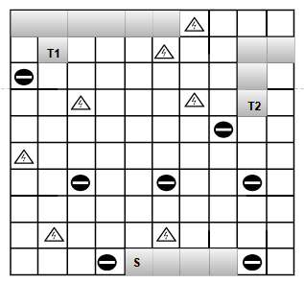
- are metals and , are obstacles

(a) | Find and draw a floor plan with the minimum total area enclosed if the global bounding box is a $20×20$ grid. | [3]
(b) | Find the Manhattan Distance from S to T1. | [2]
(c) | Using Lee’s Maze Algorithm, find the shortest path from S to T1 and T2, allowing minimum bends | [4]
(d) | Find the memory requirement for the algorithm if we use a sequence of natural numbers. If the maximum memory requirement of the provided grid is 45 bytes, find how many unique numbers starting from 0 can be used for wave propagation in Lee’s maze algorithm. | [6]

